The Phillips curve

Topic 1: Short-run and long-run Phillips curves

Difficulty Level 2
Use the graph below to answer the following question.
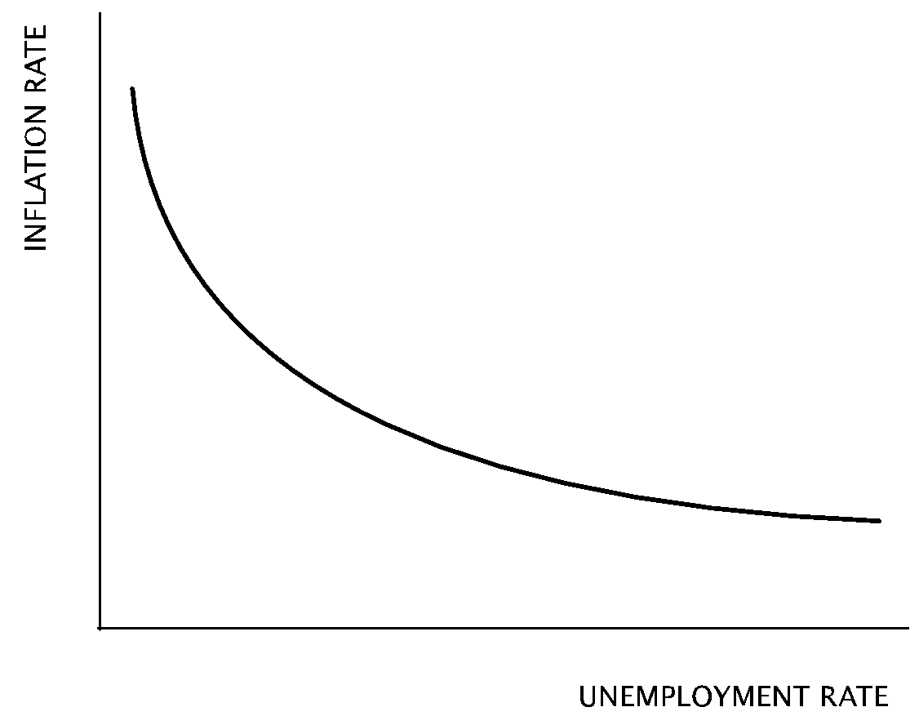
- Which curve is depicted in the graph above?
  - Production possibilities curve
  - Aggregate demand curve
  - Short-run Phillips curve
  - Long-run Phillips curve
  - Short-run aggregate supply curve
- According to the short-run Phillips curve, as the inflation rate decreases
  - the unemployment rate increases
  - the labor force participation rate increases
  - the government budget deficit increases
  - real gross domestic product increases
  - nominal wages decrease
- According to the short-run Phillips curve, a high rate of inflation is associated with
  - a low real interest rate
  - a high unemployment rate
  - a low unemployment rate
  - a decreasing money supply
  - a low reserve ratio
Use the graph below to answer the following questions.
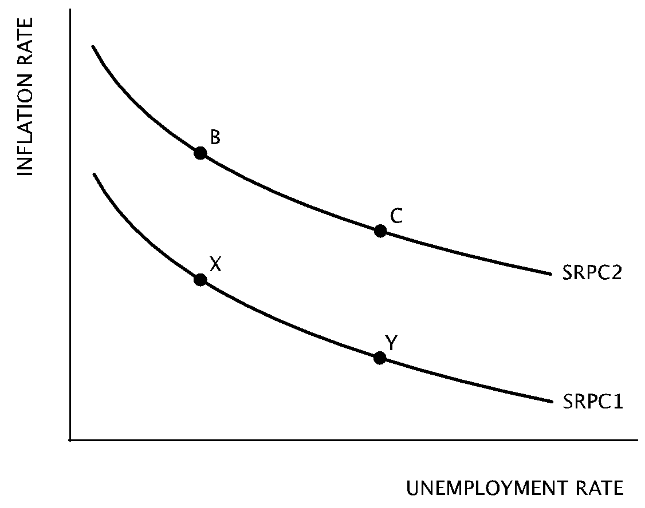
- An increase in aggregate demand will cause a movement from point
  - X to B
  - B to X
  - X to Y
  - Y to X
  - Y to B
- If the Federal Reserve implements a contractionary monetary policy, how will this policy be reflected in the graph above?
  - A movement from Point B to Point C
  - A movement from Point C to Point B
  - A shift of SRPC1 to SRPC2
  - A shift of SRPC2 to SRPC1
  - The short-run Phillips curve will be unaffected
- A leftward shift of the short-run Phillips curve is most likely due to
  - an increase in nominal wages
  - a decrease in worker productivity
  - a decrease in the price of oil
  - a increase in the money supply
  - an increase in consumption spending
- Which of the following is true of the Phillips curve?
  - It is upward sloping in the short-run and downward sloping in the long-run.
  - It is downward sloping in the short-run and vertical in the long-run.
  - It represents the trade-off between unemployment and output in the short-run.
  - It is vertical in the short-run and downward sloping in the short-run.
  - It is vertical in the long-run at a fixed rate of inflation.

- Which of the following changes could cause a movement along the short-run Phillips curve toward higher inflation and lower unemployment?
  - An improvement in the quality of capital goods
  - An increase in human capital
  - An increase in savings by the country’s consumers
  - An increase in exports
  - An increase in marginal corporate taxes
- Which of the following is true of the long-run Phillips curve?
  - It will shift if there is a change in aggregate demand.
  - It represents an indirect relationship between inflation and unemployment.
  - It represents a direct relationship between inflation and unemployment.
  - It is vertical at the natural rate of unemployment.
  - It represents the cyclical rate of unemployment.
- How will an increase in nominal wages affect the short-run Phillips curve and the long-run Phillips curve?
Short-run Phillips Curve Long-run Phillips curve
  - Shift to the right Shift to the right
  - Shift to the right Shift to the left
  - Shift to the right No change
  - Shift to the left Shift to the right
  - Shift to the left No change

Use the graph below to answer the following questions.
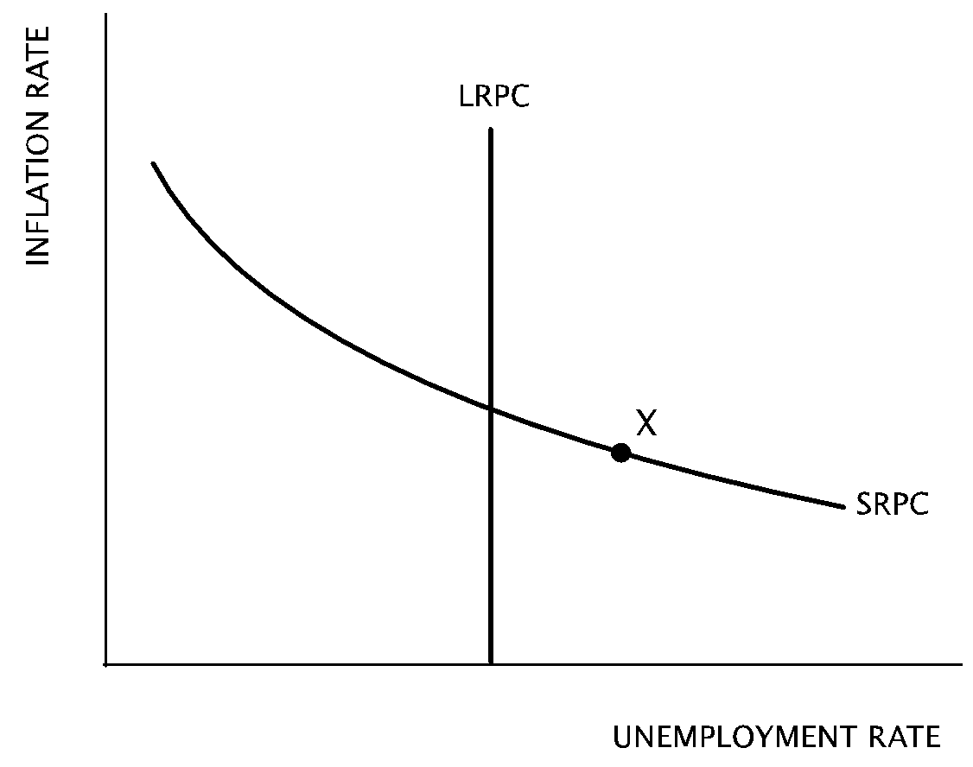
- Assuming that the economy depicted in the graph above is currently operating at Point X on the short-run Phillips curve, which of the following is true?
  - The current unemployment rate is equal to the natural rate of unemployment.
  - The current unemployment rate is equal to the non-accelerating inflation rate of unemployment (NAIRU).
  - Current output is greater than full-employment output.
  - The economy is in recession.
  - The inflation rate is increasing.
- Assuming that the economy depicted in the graph above is currently operating at Point X, how will the economy change in the long-run?
  - The unemployment rate will increase
  - The unemployment rate will be equal to the natural rate of unemployment
  - The inflation rate will increase
  - The long-run Phillips curve will shift to the right
  - Short-run aggregate supply will decrease
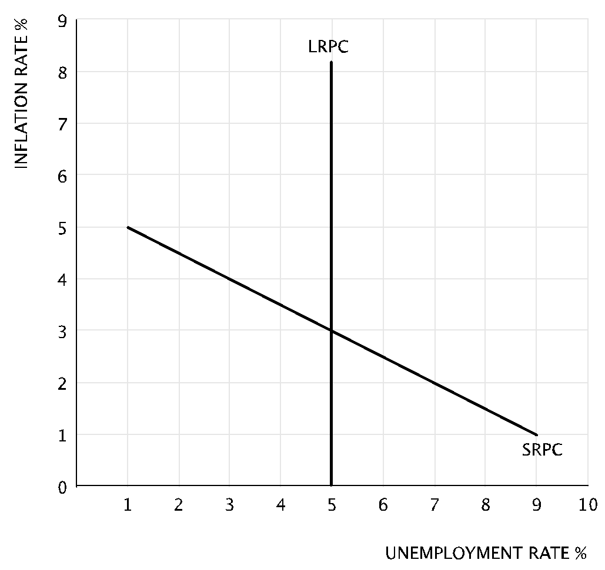
- According to the graph above, the natural rate of unemployment is
  - 1 percent
  - 3 percent
  - 5 percent
  - 9 percent
  - indeterminate
- According to the graph above, if the unemployment rate is currently 4 percent, then
  - the economy is in recession
  - the current unemployment rate is greater than the natural rate
  - the short-run Phillips curve will shift to the left
  - the inflation rate will increase in the long-run
  - the inflation rate will remain constant
Use the graph below to answer the following question.
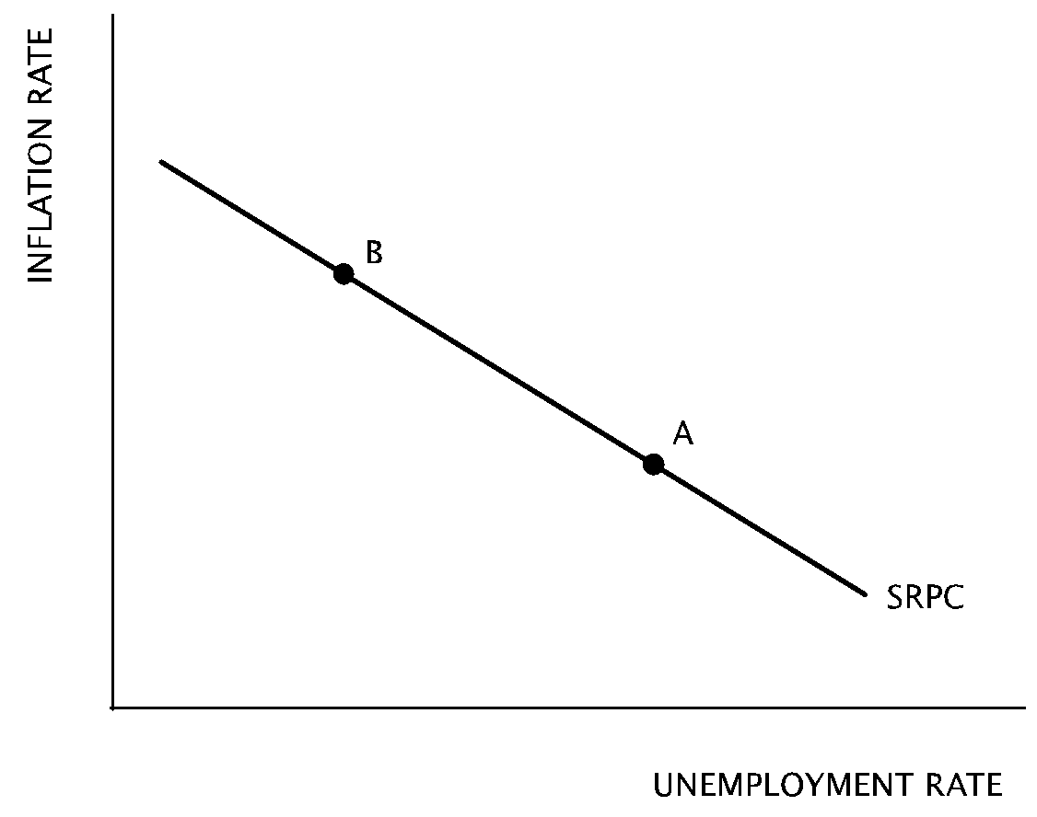
- Which of the following changes will most likely cause a movement from Point A to Point B on the short-run Phillips curve in the graph above?
  - Increase in personal income taxes
  - Increase in domestic military expenditures
  - Increase in the global supply of oil
  - Increase in inflationary expectations
  - Increase in the required reserve ratio

Topic 2: Demand-pull versus cost-push inflation

Difficulty Level 2
- Which of the following will cause demand-pull inflation?
  - An increase in short-run aggregate supply
  - An increase in long-run aggregate supply
  - An increase in aggregate demand
  - A decrease in aggregate demand
  - A decrease in short-run aggregate supply
Use the graph below to answer the following question.
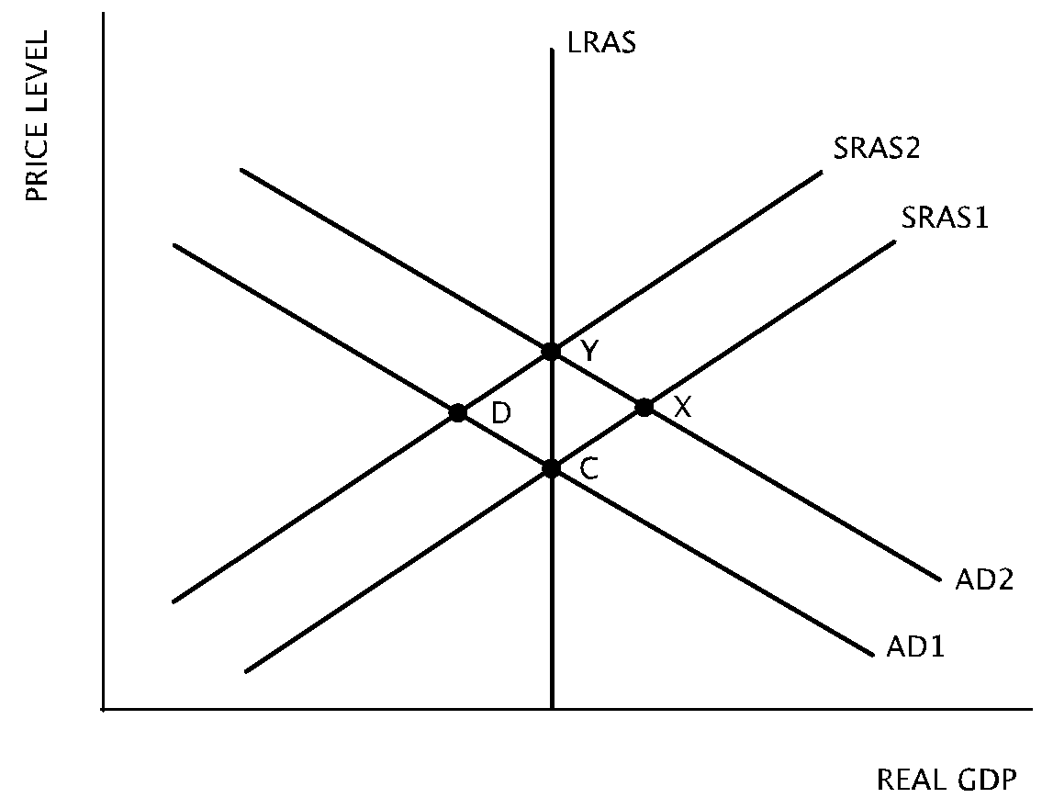
- Starting with equilibrium point C, which of the following shifts of equilibrium identifies the short-run and the long-run results of a demand-pull inflation?
Short-run Long-run
  - C to X X to C
  - C to Y Y to X
  - C toD D to Y
  - C to X X to Y
  - C to Y Y to C
- Assuming the economy is at full employment, which of the following will most likely result in demand-pull inflation in the short run?
  - A decrease in consumption spending
  - An increase in household savings
  - A decrease in the real interest rate
  - A drought that affects the entire nation
  - An increase in the demand for cell phones
- Which of the following changes will most likely cause cost-push inflation?
  - An increase in government spending
  - Crowding out
  - An increase in frictional unemployment
  - Deflation
  - An increase in the prices of steel and coal
- Assuming the government uses fiscal policy to reduce demand-pull inflation, which of the following changes will most likely result?
  - An increasing government budget deficit
  - An increase in the unemployment rate
  - An increase in nominal wages
  - A decrease in private investment spending
  - An increase in real gross domestic product
- When an economy is at full employment, which of the following will most likely create cost-push inflation in the short-run?
  - The Federal Reserve increases bond purchases
  - Lawmakers increase personal income taxes
  - Lawmakers decrease the corporate tax rate
  - Labor unions win widespread increases in nominal wages
  - Industries implement more efficient automated production methods

Topic 3: Role of expectations

Difficulty Level 2
- Which of the following changes will likely occur if there is an increase in the expected rate of inflation?
  - An increase in short-run aggregate supply
  - A decrease in long-run aggregate supply
  - A rightward shift of the long-run Phillips curve
  - A leftward shift of the short-run Phillips curve
  - A rightward shift of the short-run Phillips curve
- Which of the following changes will cause a rightward shift in the short-run Phillips curve?
  - an increase in aggregate supply
  - an increase in the expected rate of inflation
  - a decrease in the expected rate of inflation
  - an increase in aggregate demand
  - a decrease in aggregate demand
- Which of the following changes will lead to a decrease in the expected rate of inflation?
  - A decrease in income tax rates
  - An increase in the marginal propensity to consume
  - An increase in the prices of productive inputs
  - An increase in exports
  - A decrease in the money supply
- According to rational expectations theory, people
  - use all available information in forming their expectations about future inflation
  - assume that future inflation will be the same as past inflation
  - base expectations about future inflation exclusively on historical data
  - do not estimate future inflation rates
  - predict that future inflation will not change from current levels
- Which of the following changes may result in an increase in inflation and unemployment?
  - Increased purchases of capital goods
  - An increase in consumer spending
  - A decrease in the marginal propensity to save
  - An increase in inflationary expectations
  - A decrease in the price of productive resources
- Assume that the Federal Reserve implements an expansionary monetary policy. If workers believe that this policy will cause inflation and demand higher wages, they are following the principles of
  - the Phillips effect
  - adaptive expectations
  - rational expectations
  - the quantity theory of money
  - the money multiplier effect
- According to the rational expectations theory, an announced increase in the money supply will have which of the following effects on nominal and real gross domestic product (GDP)?
Nominal GDP Real GDP
  - Increase Increase
  - Increase Decrease
  - Increase No change
  - Decrease Increase
  - No change Increase
- According to rational expectations theory, which of the following will result if households and firms anticipate an expansionary monetary policy?
  - An increase in cyclical unemployment
  - An increase in nominal gross domestic output
  - A decrease in real gross domestic output
  - A decrease in the price level
  - A decrease in the natural rate of unemployment

1 | C | 11 | D | 21 | D
2 | A | 12 | B | 22 | E
3 | C | 13 | C | 23 | B
4 | D | 14 | D | 24 | E
5 | A | 15 | B | 25 | A
6 | C | 16 | C | 26 | D
7 | B | 17 | D | 27 | C
8 | D | 18 | C | 28 | C
9 | D | 19 | E | 29 | B
10 | C | 20 | B

